Unit 3: Divide and Conquer Methods
Introduction:
The divide and conquer method is an algorithm design paradigm that solves complex problems by breaking them into smaller, independent subproblems, solving those subproblems recursively, and then combining their solutions to solve the original problem. It generally follows three steps: Divide, Conquer, and Combine.
The Three-Step Process
- Divide: Break the original problem into smaller, independent subproblems that are similar to the original.
- Conquer: Solve the subproblems recursively. If a subproblem is small enough (base case), solve it directly.
- Combine: Merge the solutions of the subproblems into the solution for the original problem.

Key Examples
- Merge Sort: Splits an array in half, sorts each half, and merges the sorted halves.
- Quicksort: Chooses a pivot and partitions the array around it, sorting the subarrays.
- Binary Search: Searches a sorted array by repeatedly dividing the search interval in half.

1. Binary Search:
The general steps for both methods are discussed below.
- The array in which searching is to be performed is:
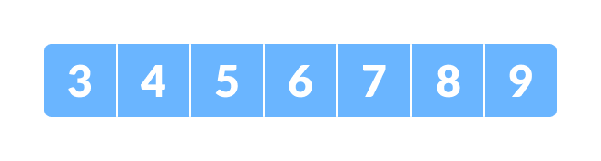
Initial array
Let x = 4 be the element to be searched.
- Set two pointers low and high at the lowest and the highest positions respectively.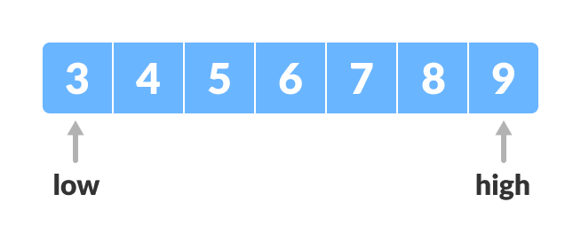
Setting pointers
- Find the middle position mid of the array ie. mid = (low + high)/2 and arr[mid] = 6.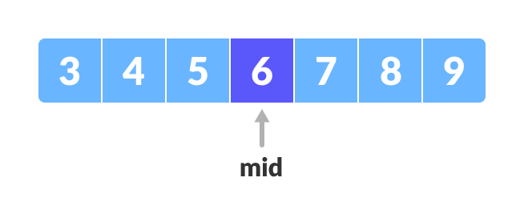
Mid element
- If x == arr[mid], then return mid. Else, compare the element to be searched with arr[mid].
- If x > arr[mid], compare x with the middle element of the elements on the right side of arr[mid]. This is done by setting low to low = mid + 1.
- Else, compare x with the middle element of the elements on the left side of arr[mid]. This is done by setting high to high = mid - 1.
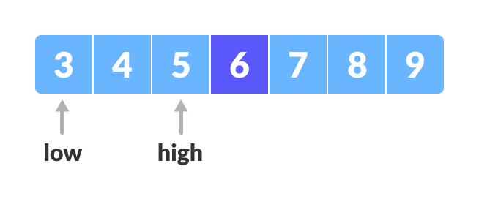
Finding mid element
- Repeat steps 3 to 6 until low meets high.
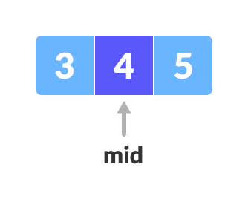
Mid element
- x = 4 is found.
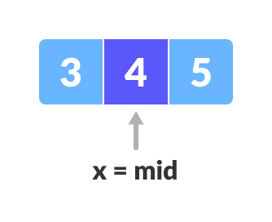

#include <iostream>
using namespace std;

// Function to perform binary search
int binarySearch(int arr[], int size, int target) {
int low = 0;
int high = size - 1;

while (low <= high) {
int mid = (low + high) / 2;

if (arr[mid] == target)
return mid;

if (arr[mid] < target)
low = mid + 1;
else
high = mid - 1;
}
return -1;
}

int main() {

int arr[] = {2, 5, 8, 12, 16, 23, 38, 56, 72, 91};
int n = sizeof(arr) / sizeof(arr[0]);
int target = 23;

int result = binarySearch(arr, n, target);

if (result != -1)
cout << "Element found at index: " << result << endl;
else
cout << "Element not found in the array." << endl;

return 0;
}

Recurrence Relation of Binary Search:

T(n) = T(n/2) + C

2. Finding the Minimum and Maximum

Finding the minimum and maximum is best achieved using the Divide and Conquer method to reduce comparisons. It divides the array into halves recursively, finding min/max in (3n/2 - 2) comparisons, which is more efficient than the linear approach of (2n-2) comparisons.
Divide and Conquer Approach
This recursive method splits the array into halves until the problem becomes trivial (1 or 2 elements).
Logic:

  - Divide: Split the array into two halves.
  - Conquer: Recursively find the min and max of each half.
  - Combine: Compare the minimums of both halves to find the overall minimum, and do the same for the maximums.

- Base Cases:
  - If the array has only one element, that element is both the min and max.
  - If the array has two elements, compare them once to determine the min and max.

- Time Complexity: O(n)
- Comparisons: If (n) is a power of 2, it requires exactly (3n/2 - 2) comparisons.

#include <iostream>

// Structure to hold both minimum and maximum values
struct Pair {
int min;
int max;
};

// Function to find min and max using Divide and Conquer
Pair findMinMax(int arr[], int low, int high) {
Pair result, left, right;

// Base Case 1: Only one element
if (low == high) {
result.min = arr[low];
result.max = arr[low];
return result;
}

// Base Case 2: Only two elements
if (high == low + 1) {
if (arr[low] < arr[high]) {
result.min = arr[low];
result.max = arr[high];
} else {
result.min = arr[high];
result.max = arr[low];
}
return result;
}

// Divide the array into two halves
int mid = (low + high) / 2;

// Conquer: Find min/max in left and right halves
left = findMinMax(arr, low, mid);
right = findMinMax(arr, mid + 1, high);

// Combine: Compare results of both halves
result.min = (left.min < right.min) ? left.min : right.min;
result.max = (left.max > right.max) ? left.max : right.max;

return result;
}

int main() {
int arr[] = {70, 250, 50, 10, 90, 400, 30};
int size = sizeof(arr) / sizeof(arr[0]);

Pair result = findMinMax(arr, 0, size - 1);

std::cout << "Minimum element: " << result.min << std::endl;
std::cout << "Maximum element: " << result.max << std::endl;

return 0;
}

For the given array arr[] = {70, 250, 50, 10, 90, 400, 30} with indices 0 to 6, the array is divided down to single or paired base cases.

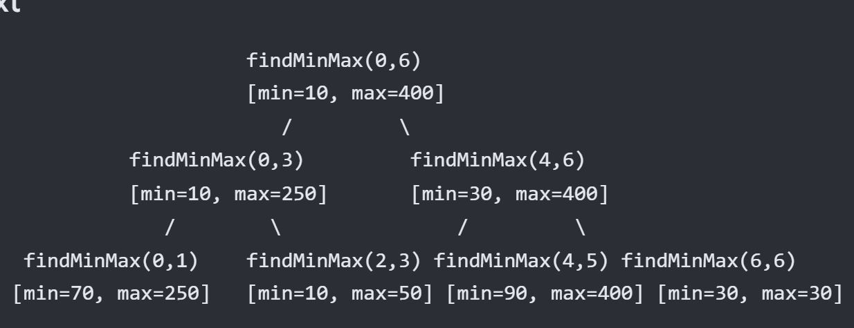

Recurrence Relation:

T(n)=2T(n/2) + 2
3. Merge Sort and Quick Sort:
T(n) = 2T(n/2) + n

4. Selection:
The selection problem (finding the k-th smallest element) is solved using divide and conquer via algorithms like Quickselect. It partitions the array around a pivot, recursively searching only the partition containing the target, achieving average linear time O(n) complexity, rather than sorting the entire array.

Selection algorithm to find the k-th smallest element:

Divide and Conquer Selection Approach (Quickselect)
The selection procedure uses a similar approach to Quicksort, relying on the partitioning algorithm to find the k-th smallest element.
- Divide: Choose a pivot element and partition the array into two subarrays: elements less than the pivot and elements greater than the pivot.
- Conquer: Instead of recursing into both sides (like Quicksort), identify which side holds the k-th smallest element.
  - If the partition index j equals k, the pivot is the result.
  - If k < j, recursively search the left partition.
  - If k > j, recursively search the right partition.
- Combine: The solution is directly returned from the recursive call.

FUNCTION quickSelect(arr, left, right, k)
// Base Case: If the partition contains only one element
IF left == right THEN
RETURN arr[left]
END IF

// Divide step: Partition the array and get the pivot's final index
pivotIndex = partition(arr, left, right)

// Conquer step: Check if the pivot index matches our target index (k - 1)
IF pivotIndex == k - 1 THEN
// Found the kth smallest element
RETURN arr[pivotIndex]

ELSE IF pivotIndex > k - 1 THEN
// Target is in the left subarray; discard the right half
RETURN quickSelect(arr, left, pivotIndex - 1, k)

ELSE
// Target is in the right subarray; discard the left half
RETURN quickSelect(arr, pivotIndex + 1, right, k)
END IF
END FUNCTION

See class note for Stressen matrix Multiplication.

